**Project Design Phase-II**

**Data Flow Diagram & User Stories**

|  |  |
| --- | --- |
| Date | 15 October 2022 |
| Team ID | PNT2022TMID08854 |
| Project Name | DemandESt AI powered Food Demand Forecaster |
| Maximum Marks | 4 Marks |

**Data Flow Diagrams:**

A Data Flow Diagram (DFD) is a traditional visual representation of the information flows within a system. A neat and clear DFD can depict the right amount of the system requirement graphically. It shows how data enters and leaves the system, what changes the information, and where data is stored.

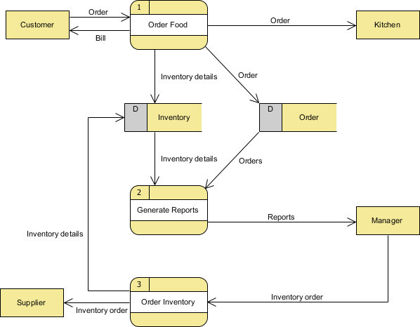

**User Stories**

Use the below template to list all the user stories for the product.

| **User Type** | **Functional Requirement (Epic)** | **User Story Number** | **User Story / Task** | **Acceptance criteria** | **Priority** | **Release** |
| --- | --- | --- | --- | --- | --- | --- |
| Customer (Mobile user) | Registration | USN-1 | As a user, I can register for the application by entering my email, password, and confirming my password. | I can access my account / dashboard | High | Sprint-1 |
|  |  | USN-2 | As a user, I will receive confirmation email once I have registered for the application | I can receive confirmation email & click confirm | High | Sprint-1 |
|  |  | USN-3 | As a user, I can register for the application through Facebook | I can register & access the dashboard with Facebook Login | Low | Sprint-2 |
|  |  | USN-4 | As a user, I can register for the application through Gmail | I can receive confirmation  Gmail & click confirm | Medium | Sprint-1 |
|  | Login | USN-5 | As a user, I can log into the application by entering email & password | I can receive confirmation email & password | High | Sprint-1 |
|  | Dashboard | USN-6 | AS a user I can check the facilities of the Dashboard | I can receive and help to more support in the Dashboard | High | Sprint-2 |
| Customer (Web user) | Web user | USN-7 | As a user I can use this website to learn more about this quantity method | I can receive confirmation & click to check the quantity | Low | Sprint-2 |
| Customer Care Executive | Customer support | USN-8 | As a user I can need to want an customer support care | I can receive your queries accept the confirmation | Medium | Sprint-1 |
| Administrator | Admin | USN-9 | AS a user I can see your varieties of the products | I can receive your product to check confirmation | Medium | Sprint-2 |
|  |  | USN-10 | As a user I can see your products of the Ingredients | I can receive your Ingredients to check confirmation | High | Sprint-3 |
|  |  | USN-11 | AS a user I can compare your product with another administrator website | I can receive you to compare another product confirmation | Medium | Sprint-2 |
| Customer(order) | Order | USN-12 | As a user I can order to delivery a product of items | I can receive your order to verify the delivery of the product | High | Sprint-1 |